Project Report for A Non-Invasive Wireless Respiratory Monitoring System for Animals

## Abstract

The objective of the project is to develop a biomedical device that can noninvasively monitor a dog’s heart rate using a conductive fabric. Nowadays more and more people are keeping dogs as their loyal companions. According to statista.com, the number of pet dogs has increased from 68 million in 2000 to 89.7 million by 2017. As such the need for simple reliable and cheap heart rate sensor for dogs will also be increasingly demanded. Our device can really simplify the dog heart rate sensing technology making them more affordable and reliable for a dog or even other pet owners.

## Introduction

The approach towards this project is to measure the breath rate of a dog which is related to its heart rate by detecting the movement of the dog’s chest. The resistance of the fabric will vary as the dog’s chest stretches the fabric. Using a resistance to voltage convert circuitry, we generate a voltage signal that is correlated with the movement of the dog’s chest. This signal is captured using a microcontroller and then together with the temperature readings from a temperature sensor they will be sent over to a computer wirelessly for further process and analysis. This custom-made sensor-microcontroller device is attached to a dog harness. Finally, in our computer, we would filter out all the noises and measure the number of pulses which represents the breath rate and ultimately heart rate from the signal. The recorded data can be used in analyzing, diagnosing and improving the dog’s health conditions.

## Design and implementation

The device consists of 3 part which is the sensor, microcontroller, and desktop application. The core component is a rubber cord stretch sensor it would capture the chest movement of the dog with an electrical signal. The signal is then recorded by the microcontroller and sent to the desktop through Wi-fi. On the desktop application, the signal is further processed and analyzed. In addition, the desktop application is act as a controller of the operation of the device. In addition, we have a temperature sensor so that we can take dog’s temperature measurements as well. The following is a flow chart for the operation of the device.

The hardware mainly consists of an Adafruit HUZZAH32 board, a 350mah lithium polymer battery, and a power switch.

The Adafruit HUZZAH32 board carries an ESP32 microcontroller, which has got an Xtensa dual-core 32-bit LX6 microprocessor which runs at 240MHz, 520kB SRAM, 2 onboard ADC with 12 channels and a variety of wireless communication method including Wi-Fi, Regular Bluetooth, and BLE, which perfectly fit our needs.

3.3v VDD

10kOhm

Rubber cord (in blue)

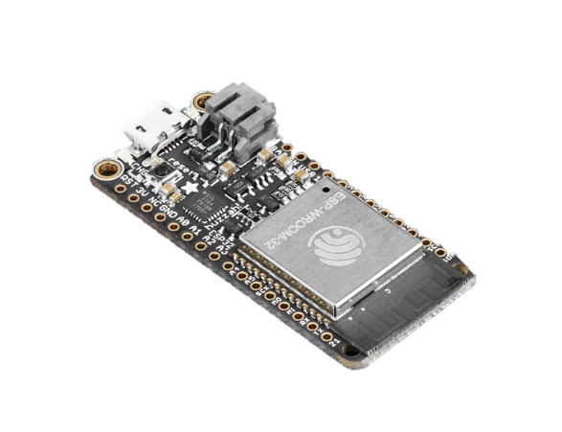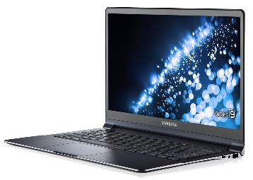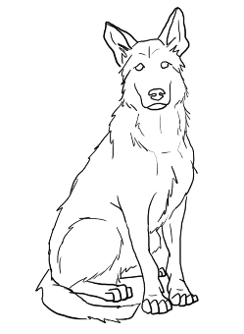

In addition, the board has got a miniature shape that is perfect for a wearable device. To make the device wearable we put the microcontroller in a 3D printed case and mount it on a dog harness.

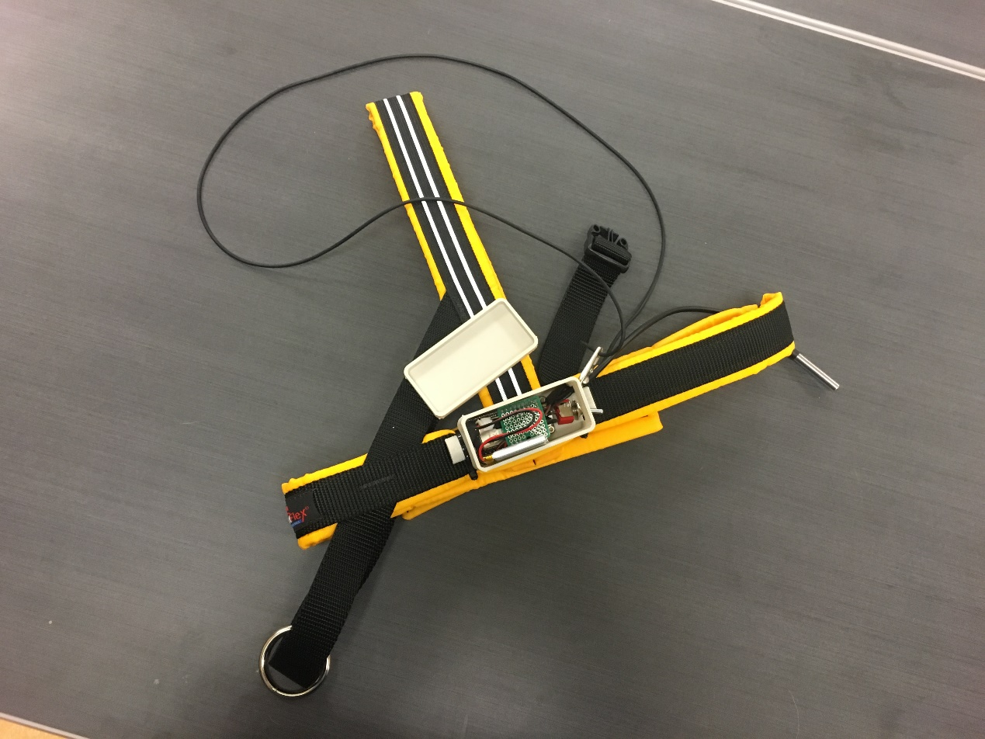

The software design uses a server-client model. The microcontroller which is generating all the data will be assigned as the server, and the PC which is receiving all the data will be considered as the client.

The server program was developed using Arduino IDE. Details of how to set up and develop in Arduino IDE can be found on Adafruit website (Ada, 2017).

The server program would initialize the Wi-fi and connect to the designated hotspot “Dog_temp” which is broadcasted by the PC, and then wait for a client connection. After the connection is established the server will start the corresponding measurement according to the command sent over by the client. After that, the data will be sent through Wi-fi. This process will repeat until the client disconnect.

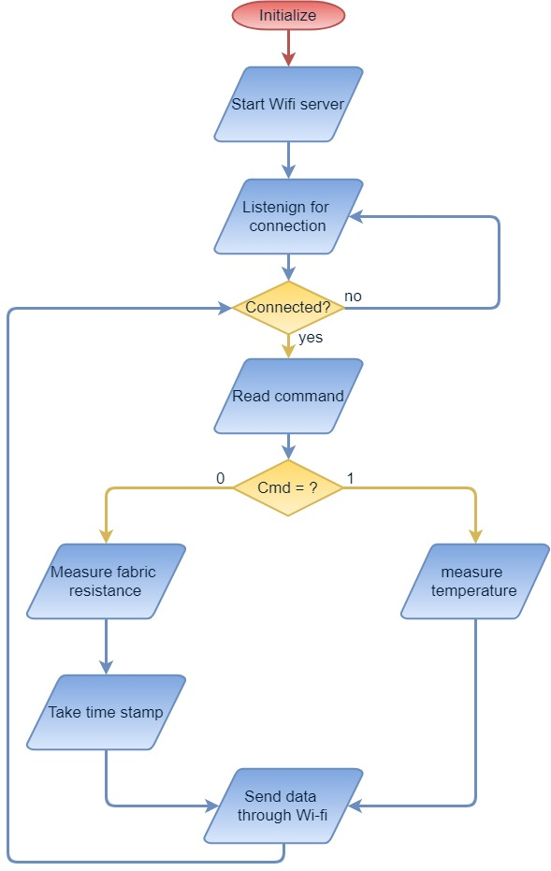

On the PC side, before starting the client, we need to first enable the Wi-fi hot spot in our laptop. The hot spot needs to have the same name and password as specified in the server program.

The client program was developed with MATLAB Instrument Control Tool Box and GUIDE.

After the program is finished the MATLAB application compiler will package it into a standalone application. There are four steps after the user pressed the start measurement key: take breath rate measurement (i.e. the fabric resistance data), signal process and calculate breath rate, take temperature data, record data.

At each measurement phase, the client will send out command first and then continuously read the measurement till the specified time was reached.

Details are included in the following flowchart.

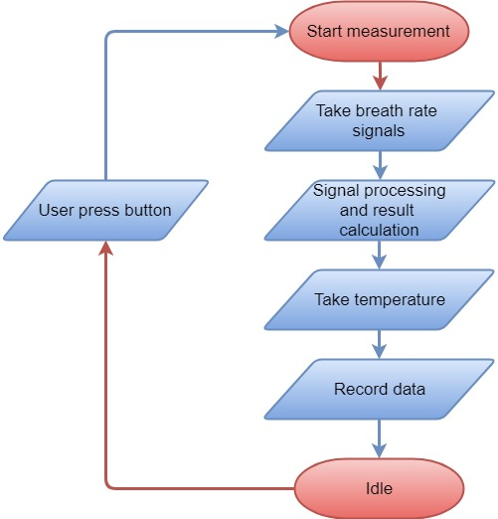

Signal processing is included in the application so that we can obtain a signal with clear pulse separation. The breath rate signal is expected to be around 1-2Hz with a triangular shape with a certain amount of noise. As such a low pass filter with 7Hz of the cutoff frequency, to get rid of the high-frequency noise. To preserve the triangular shape additional harmonics were added. The filter can be described by the equation:

The following plot shows the shape of the filter in the frequency domain.

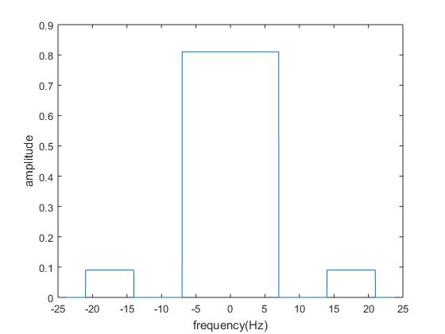

## Operation and testing

Before we can use the device, we need to install the desktop application with the precompiled installer. And make sure that MATLAB runtime library was installed as well.

To use the device, we need to follow the following steps:

1. Start the mobile hotspot on our computer with network name “Dog_temp” and password “12345678”.
2. Turn on the microcontroller power switch, the red LED will be on if the hotspot is detected.
3. Start the application, input the time we want to measure, and press the start button. The result will be shown in the table along with the graph of our signal in a new graph window when the measurement is finished

The testing of the device includes a lab environment test and real environment test. In the lab environment test the stretch will be generated by hand and in real environment test the device will be mounted on a dog

The goal is to obtain a signal with clear pulses and have the MATLAB to recognize and count every single one of them. Here’s a snapshot of the test results.

Lab environments:

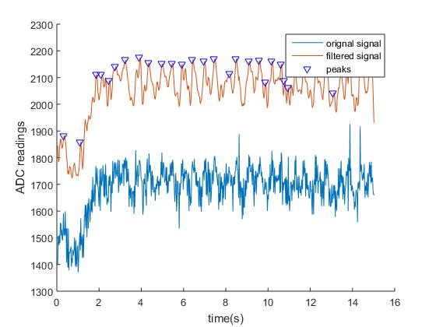

Real environment:

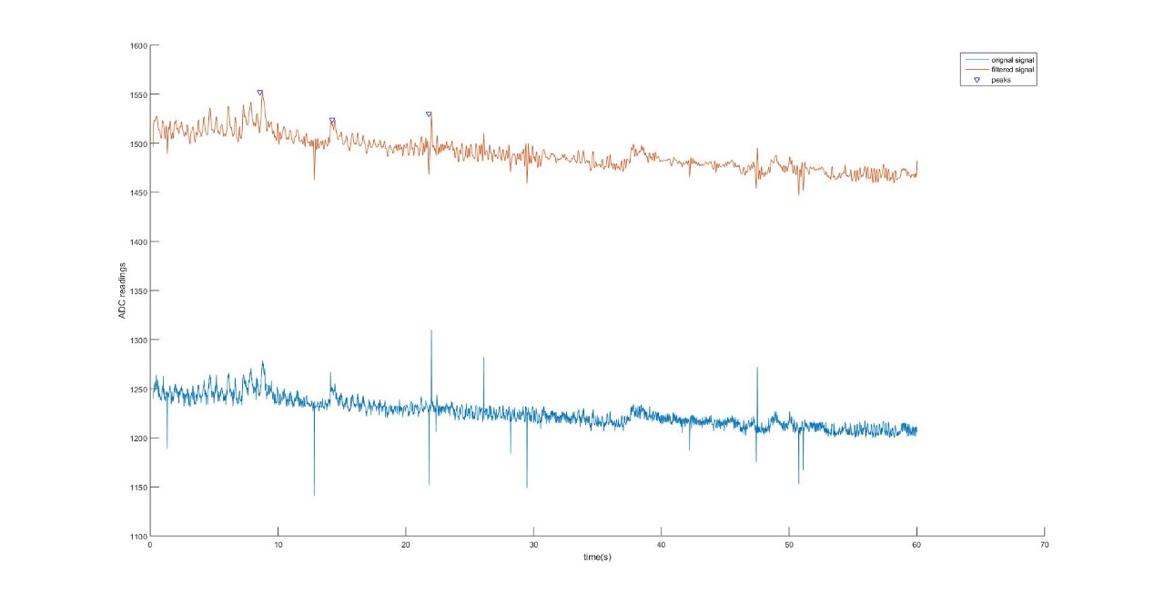

From the result, we can see that the signal processing and pulse counting mechanism do not work perfectly in a real environment as they did in a lab environment.

## Conclusion

In this project, we developed a wearable breath rate sensor with a wireless communication capability for dogs. We demonstrated our capability to collect breath rate data and transmit them through Wi-fi. However, due to the non-idealities of the signal measured from the dog, such as muscle movement, device vibration or any form of an unexpected stretch of the rubber cord will cause a disturbance, thus resulting in inaccurate measurement of breath rate. We would still need to further improve our signal processing of the raw data and the pulse recognition and counting mechanism. As the continuation of this work, aside from the improvement previously mentioned, we will be adding more diagnostic tools for measuring dogs’ heart rate. Such as measuring heart rate variability of a dog.